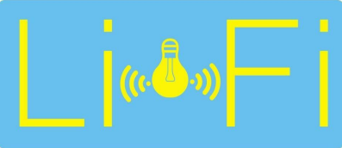

LI-FI

(Light Fidelity)

FUTURE OF WIRELESS TECHNOLOGY

GROUP MEMBERS

11508 Muzamil Khan

**Submitted To**:

ABSTRACT

Light Fidelity (Li-Fi) is a Visible Light Communication (VLC) based technology that making a light as a media of communication replacing the cable wire communication. Li-Fi is evolve to overcome the rate speed in Wi-Fi, while using Li-Fi the rate speed can reach until 14 Gbps. This paper presents an introduction of the Li-Fi technology including the architecture, modulation, performance, and the challenges. The result of this paper can be used as a reference and knowledge to develop some of the Li-Fi technology. In our daily routine, one of the most important tasks we can perform is to move data from one place to another. There is no doubt that wireless communication plays a vital role in today's society. The wireless network information has a much-needed value however; the current wireless networks are slow when most devices are connected to the internet. Wi-Fi is based on radio waves. As the number of devices connected to the Internet increases, the fixed bandwidth makes it difficult to transmit data easily, as radio waves are a small part of the data transfer industry. As radio waves penetrate between the walls, one can misuse them and this can cause security concerns over Wi-Fi. Like most technologies, Wi-Fi also has some limitations as its bandwidth is often limited. Also, radio waves are restricted in certain areas such as aero airports, hospitals, petrol pumps and petrochemical plants. Therefore, in such places we cannot connect to the internet. Wi-Fi provides good data transfer but does not allow big data such as HDTV movies, music libraries and video games. To overcome such problems Li-Fi technology is being developed.

CONTENT

**INTRODUTION4**

**VISUAL LIGHT COMMUNCATION5**

**HISTORY OF LI-FI6**

**COMPONENTS OF LI-FI7**

**LED (LIGHT EMITTING DIODE) 7**

**PHOTODIODE8**

**COMMUNICATION CHANNEL8**

**HOW LI-FI WORK?9**

**LAYERED ARCHITECTURE OF LI-FI10**

**PHYSICAL LAYER 10**

**MAC LAYER11**

**PEER TO PEER11**

**STAR11**

**BROADCAST11**

**MODULATION TECHNIQUES12**

**LI-FI Vs. WI-FI13**

**INTRODUCTION13**

**DIFFERENCES14**

**COMBINATION14**

**APPLICATIONS14**

**ADVANTAGES OF LI-FI15**

**DISADVANTAGES OF LI-FI15**

**APPLICATION OF LI-FI16**

**IMPACTS OF LI-FI ON SOCIETY25**

**FUTURE SCOPE OF LI-FI26**

**PROBLEM STATEMENT27**

**THESIS STATEMENT27**

**CONCLUSION28**

**REFERENCES30**

1. INTRODUCTION

Li-Fi is a wireless communication system where light is used as a network signal instead of the traditional radio frequency such as Wi-Fi. It uses light emitting diodes (LEDs) to transmit data without wire. It is a safe, raw and cheap technology as it does not have radio waves or any other type of waves. The man who found this technology was Professors Herald Hass. The LI-FI provides us a great power and security when we compare it to WI-FI. LI-FI works on principles of VLC (Visual Light communication). In VLC a high-speed light source is used to transmit data other than wire that is not accessible to the human eye. If you look at both sides, it looks like it could be a tough competition between WI-FI and LI-FI. In this report, we will provide an introduction and details about LI-FI, its history, VLC, its basic structure, LI-FI flexibility strategies, comparisons between LI-FI and WI-FI and its pros and cons, Li-Fi Applications, Future Scope and Final Conclusion.

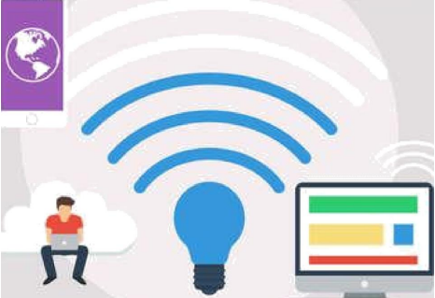

1. VISUAL LIGHT COMMUNCATION(VLC)

The VLC (Visible light communication) is communication technology which uses the visible light source for transmitting of signal and for transmission medium it uses air and suitable photo diode as a signal receiving component.

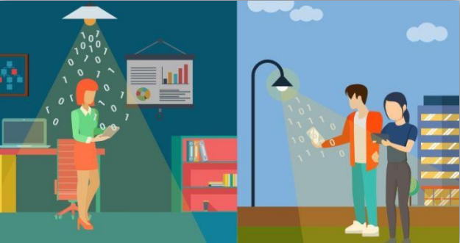

1. HISTORY OF LIFI

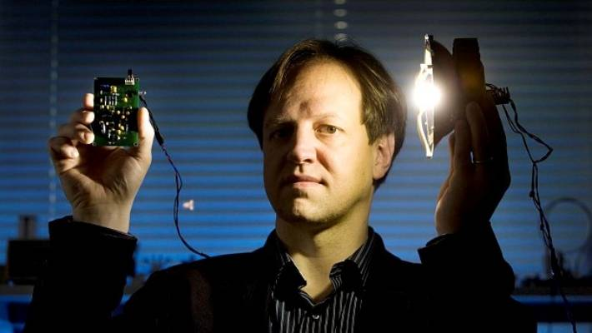

LI-FI (Light Fidelity) was first introduced by Professor Harald Haas with his team including Dr. Gorden Povey, Dr. Mostafa Afghani in July 2011 at TED Global Talk. Professor Harald Haas, of the University of Edinburgh in the UK, is widely known as the first founder of Li-Fi. He named it Li-Fi and is the Chair of Mobile Communications at the University of Edinburgh and is the founder of Pure Li-Fi. Scientist Harald Hass called this technology (Light through illumination).

1. COMPONENTS OF LIFI

* LED (light emitting diode)
* Photodiode
* Communication channel
  1. LED (LIGHT EMITTING DIODE):

A light-emitting diode (LED) is a semiconductor light source that emits light when current passes through it. In the transmitter end LED light is used to convert the electrical signal into a light signal. Choosing the appropriate light source depends on how fast the source can switch between high to low. For such reason, the fluorescent bulbs are not a good choice for the source where LED serves this purpose well, in a LED due to the change of energy, photons are generated Which are emitted in form of light. Such a design allows LEDs for frequent switching. LEDS can produce thousands of data streams throughout the whole room thus light reaches every corner of the room providing high-speed data transfer.

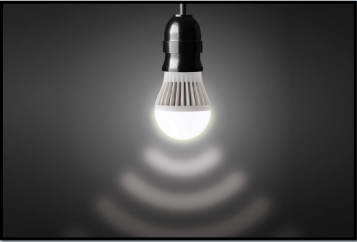

* 1. PHOTODIODE:

The photodiode is used for detecting the data coming from the transmitter side thus acting as a receiver: Photodiodes convert the received light signal back to electrical signal, selecting of the receiver photodiode in LI-FI system is the hardest part. This technology is new so there are not many photodiodes available that provides the purpose of the LiFi receiver. Things to be examined while selecting the photodiode are large radiant sensitivity area, very high response time, and high sensitivity between 780nm-375nm spectral bandwidth.

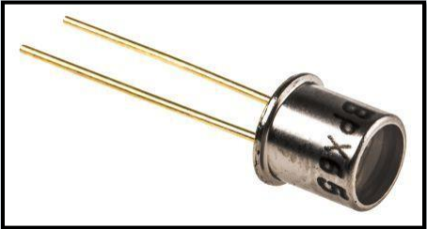

* 1. COMMUNICATION CHANNEL

The channel used for communication in Li-Fi system is the free space. That means the light from the transmitter travels towards the receiver photodiode through the free space thus creating a wireless communication system. Well, this free space provides the main drawback in the Li-Fi technology that is the interference coming from the other light sources which also produces visible light.

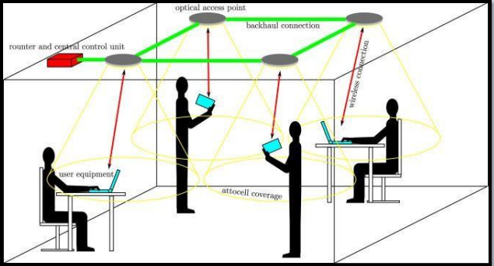

1. HOW LI-FI WORKS?

Li-Fi are terms used to describe optical wireless technology. Li-Fi is working on a Simple System. In this technique, light emits on one end, for example, an LED, and a photo detector on the other. The photo detector detects a binary one when the LED is on, and a binary zero if the LED is off.

A LiFi network uses the light from LED lamps to send data to a device, such as a laptop or tablet. The device has a receiver to pick up light signals and a transmitter to send light signals back to the lamp using infrared light.

A LiFi network still needs a regular internet service provider to supply internet to a home or office via wires. LiFi can then be deployed within a home or office to provide a wireless internet connection to devices.

This is the most up-to-date Internet service, but it is insufficient for transmitting large data files such as HD movies, music libraries, and video games. And most of the people are dependent upon ‘the cloud service’ or our own ‘local storage device’ to store all our files, including movies, photos, audio, and video devices, games, for that we require a large amount of bandwidth and speed to access this data.

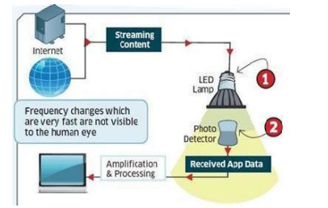

1. LAYERED ARCHITECTURE OF LI-FI

In layered architecture, Li-Fi consist of 3 stages.

* Application layer
* MAC layer
* Physical Layer

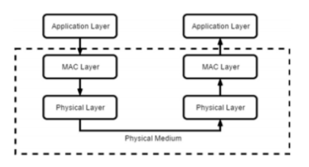

## PHYSICAL LAYER

Physical layer responsible in transmission and reception, activation and deactivation of optical transceiver, and detection of state of transmission channel, is it idle or busy state.

There are 3 operation modes in Physical layer, below are some key points which show the differences among them;

**PHY I USAGE:** Outdoor Categories: Low 11.6 Rate: 11.6 Kbps – 266.6 Kbps

**PHY II USAGE:** Indoor Categories: Moderate Rate: 1.25 Mbps – 96 Mbps

**PHY III USAGE:** Multiple optical transceiver Categories: CSK Modulation Rate: 12 Mbps – 96 Mbps.

### MAC LAYER

MAC LAYER is responsible for flow control and multiplexing for transmission medium. Three network topologies are defined in MAC layer.

* Peer to peer
* Star
* Broadcast
  + 1. PEER TO PEER:

There are two device that communicate. One of them is act as a coordinator.

* + 1. STAR:

Communication happens in several devices. One of them is act as a coordinator and it’s used as a illumination infrastructure.

* + 1. BROADCAST:

One device i.e. A coordinator sends data to a several devices. The communication is unidirectional way.

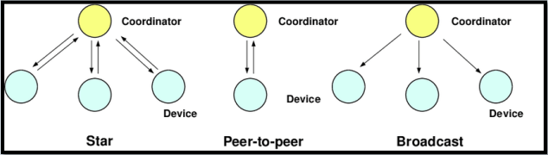

1. MODULATION TECHNIQUES

Modulation techniques are generally used when Li-Fi is summarized, and some special issues as well needs are discussed. Some techniques are:

Digital Modulation: Digital Modulation is a technique which can be used for wireless optical communication using LEDs.

Intensity Modulation: It use is depending on the intensity of light. Higher-order modulation techniques such as M-level quadrature amplitude modulation (MQAM) are essential to obtain a data rate of that is close to the Shannon capacity limit. mapping of signals from bipolar to unipolar power in a way that outperforms the performance of existing methods, such as:

* Direct current optical-orthogonal frequency division multiplexing (DCO-OFDM)
* Clipped optical-orthogonal frequency division multiplexing (ACO-OFDM)

The LI-FI and WI-FI system requires high average optical power as it uses the li9ghting system techniques. It gives a high-amplitude signal of higher-order modulation schemes clipped by the height power constraints of the LED, it should be led to high signal distortion. To solve this Hadamard Coded Modulation (HCM) was introduced to achieve to create low error probabilities in LED-based VLC systems needing high average optical powers. This technique uses a quick Walsh-Hadamard Transform (FWHT) to modulate the information which is an alternative modulation technique to orthogonal frequency division multiplexing (OFDM).

1. LI-FI Vs WI-FI
   1. INTRODUCTION:

Li-Fi and Wi-Fi are two different things. Both have their own uses, methods, and have their own application they are used on. Li-Fi is called Light Fidelity and Wi-Fi is called wireless Fidelity. The common thing between them both is that they both are used in Internet Based applications and both are wireless methods of data transmission.

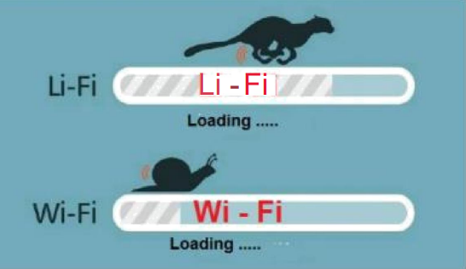

* 1. DIFFERENCES:

|  |  |  |  |
| --- | --- | --- | --- |
|  |  | **Li-Fi (Light Fidelity)** | **Wi-Fi (Wireless Fidelity)** |
| **1** | **Medium** | Light (visible light communication ) | Electro-magnetic waves (radio frequency communication ) |
| **2** | **Technology** | optical communication | radio communication |
| **3** | **Security** | It is secure | Not much secure. |
| **4** | **Data Transfer Speed** | 500Mbps, up to Gbps, 100Gbps | 11 Mbps |
| **5** | **Density of data** | High Dense Environment | Low Dense Environment |
| **6** | **Frequency Range** | 10000 times freq. than Wi-Fi | 3 GHZ – 3000 Ghz |
|  | **Operating frequencies** | 100THz | 2.4GHz, 4.9GHz, 5Gz |
| **7** | **Cost** | Less than Wi-Fi (Because it used light) | Higher than Li-Fi (A it need radio spectrum) |
| **8** | **Topology** | Point To Point | Point Multi Point |
| **9** | **Distance of Coverage(Bandwidth)** | 10 Meters Approx. | Based on Transmission Power (10 – 100 meters) |
| **10** | **Device Compliance Standard** | IEEE 802.15.xx Standard (IrDA compliant devices.) | IEEE 802.11xx standard |
| **11** | **Components Used** | Light (LED)Bulb, Photo Detector, Lamp Driver | Routers, access points(PCs, laptops) |

* 1. COMBINATION:

Combining Li-Fi and Wi-fi can provide amazing and innovative features and ideas that can be implemented in future work. Which include security, fast data rate etc. Combination of Li-Fi and Wi-Fi is done by two methods. The hybrid technique and the aggregation technique. Hybrid method is the unidirectional Li-Fi link is used to enable downlink Wi-Fi. Which aggregation method using bidirectional connection mean both Li-fi and Wi-fi links are fully used and utilized.

* 1. APPLICATION:

**Li-Fi:** Offices, Homes, Hospitals for transferring data and browsing,

Airlines

**Wi-Fi:** Internet browsing using Wi-fi Hotspots

1. ADVANTAGES OF LI-FI

* Li-Fi technology has no effects on living thing like other wave have. For example radio wave and communication waves can effect humans, birds etc. Gamma rays on direct contact are very dangerous. And X-rays can many health issues.
* As we can find light anywhere during the day and night so there are very low chances of shortage. And with Li-fi internet can be found and used anywhere where there is light.
* Li-Fi provides more security as it cannot pass through objects so no data is scattered and it remains stored in the light source.
* Li-Fi is a more efficient way for energy consumption. It can be used by light lightening which is easily available in homes, offices and it can be used to transmit data so it is cheap and consumes less energy.
* It has high speed and data transmission up to 10GBPs.
* Light can transmit a large amount of data compared to others waves so It gives a quick way of data transmission.
* Li-fi have effect on electromagnetic interferences. So it can be using in clinics, airplanes and other places where radio wave, electromagnetic and other waves are widely in use.

1. DISADVANTAGES OF LI-FI

* It can pass through objects so it may cause disturbances it its way.
* Sunlight, natural can affect its data transfer speed.
* Li-fi has a limited reach of data transfer. I order for it to have longer reach light source must be places on different positions in its way.
* It can get more costly and slow if large no of users are using it. Costly because it may need more LED Sources.
* Li=Fi request Light in its surrounding so in bad weather it cannot be used.
* It works on light source so on power shortage It cannot it shut down the Li-Fi.
* We couldn’t transfer data from an enclosed room to another enclosed room.

1. APPLICATIONS OF LI-FI

The goodly growth in the use of Light Emitting Diodes for lighting provides the chance to include Li-Fi technology into an abundance of LED environments. Li-Fi will work smoothly on internet applications and for downloading and streaming online content. These applications spot heavy demands on the downlink bandwidth, but need minimum uplink capacity. In this way, the majority of the internet traffic is off-loaded from live RF channels, thus also increase cellular and Wi-Fi capacities. There are many applications for Li-Fi. These include:

**RF Spectrum Relief:** Overconsumption capacity demands of cellular networks can be off- loaded to Li-Fi networks where available. This is mainly effectual on the downlink where bottlenecks tend to happen.

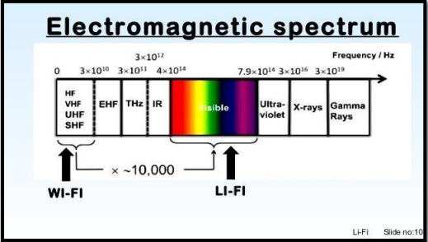

**Smart Lighting:** Any lighting private or public lighting containing street lamps can be used to supply Li-Fi hotspots & the same transmission and sensor infrastructure can be used to observe and manage lighting and data.

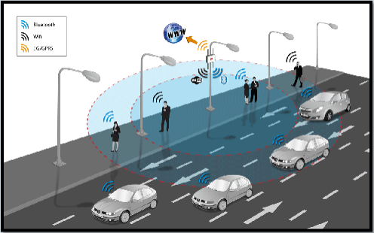

**Mobile Connectivity:** gadgets like Laptops, smart phones, tablets can interconnect directly using visible light communication (VLC). Short range links provide very high data rates and also give security.

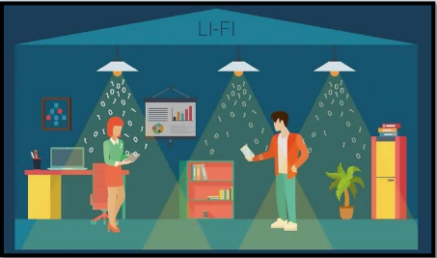

**Hazardous Environments:** Visible light communication (VLC) supplies a safe replacement to electromagnetic interference from radio frequency (RF) communications in environments such as mines and petrochemical plants. LI-FI would be intrinsically safe to use in hazardous environments where Wi-Fi is prohibited.

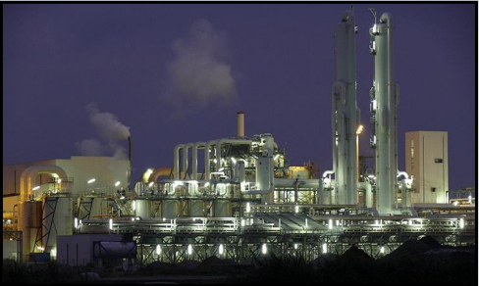

**Underwater Communication:** Due to strong signal occupation in water, RF (radio frequency) use is inappropriate. Acoustic waves have very low bandwidth and interrupt marine life. Li-Fi give solution for short-range communications.

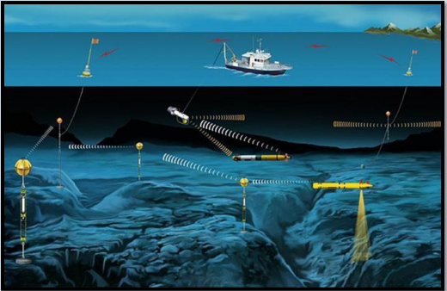

**Aviation:** Li-Fi (light fidelity) can be used to overcome weight and cabling and add durability to seating format in aircraft passenger cabins where LED (light emitting diodes) lights are already installed. In-flight entertainment (IFE) systems can also be supported and merge with passenger’s mobile devices.

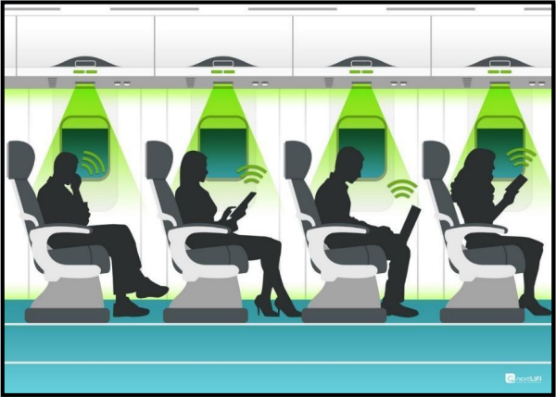

**Hospital & Health Care:** Visible light communication (VLC) releases no electromagnetic interference and so doesn’t stand in the way with medical instruments, nor is it impede with by MRI scanners. As the sue of radio frequencies (RF) are limited in hospitals, so for communication we can use Li-Fi. Patient data can be sent to doctor via Li-Fi communication. Further we are sending the same data on server so that if doctor is not accessible in hospital, he can access it by internet and can take action. This system will be much useful in hospitals.

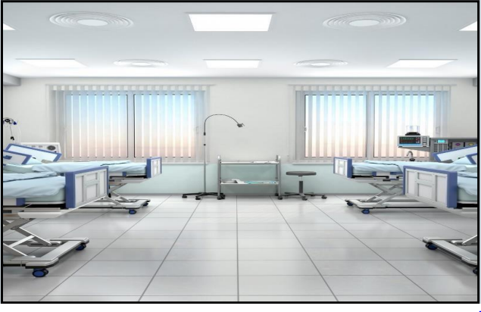

**Vehicles & Transportation:** LED (light emitting diodes) headlights and tail-lights are being introduced signage, Street lamps and traffic signals are also transferring to LED. This can be making use of for vehicle-to-vehicle and vehicle-to-roadside communications. This can be put for road safety and traffic management.

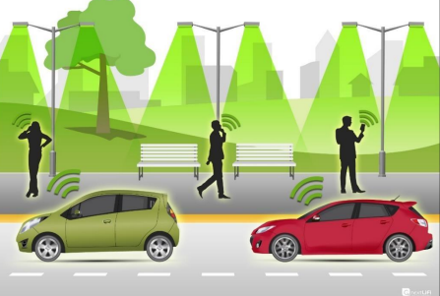

**Location Based Services:** Highly precise location-specific information services such as advertising and navigation that authorize the receiver to receive suitable, relevant information in a timely manner and location.



**Toys:** Many toys include LED (light emitting diodes) lights and these can be utilized to allow very low- cost communication among interactive toys.

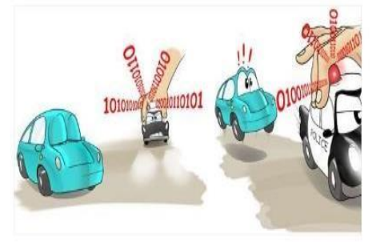

**Education Systems:** Li-Fi (light fidelity) is the latest technology that can supply rapid speed internet access. So, it could be replacing Wi-Fi at educational institutions and at companies so all the people can build use of Li-Fi with the similar speed intentional in a particular area.

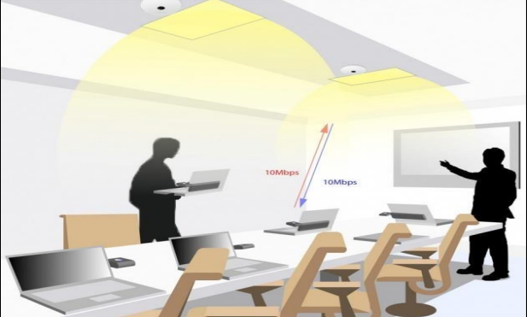

**Traffic Management:** In traffic signals Li-Fi (light fidelity) would be use which will communicate with the LED lights of the cars which could help in maintain the traffic in a good manner and the number of accidents would be decreased. Also, LED car lights would be alert drivers when other vehicles become too close.

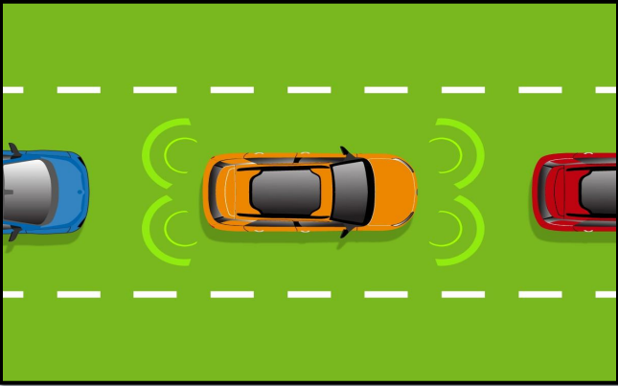

1. IMPACTS OF LIFI ON SOCEITY

Li-Fi has the power to transform society in many ways. Li-Fi can be used in current infrastructure such as wireless antenna towers. If the world turns to Li-Fi the bulk of the energy produced in fossil fuels can be saved and the current energy crisis will eventually end and the effects on the environment such as pollution caused by the production of fossil fuels will be reduced. Li-Fi is likely to be available in almost every home and office for the next 20 years. The founder of Li-Fi technology believes that in the next ten years Li-Fi will be more efficient and marketable. If you are not yet able to detect light wavelengths in sequence or a combination of data being transmitted. For proper functioning Li-Fi needs to be turned on.

* Line of sight would cause problems with Li-Fi technology, if the LED light does not conflict with the receiver installed on your laptop or phone this may stop data connection. If you are using the internet in your living room and want to get into your bedroom, you may need another LED light to use the internet or you may be out of luck.
* Our use of the Internet will depend on the source of light, which is the source of the inefficiency of light that deprives us of access to the Internet.
* The various categories of LED’s (Laser LED, Larger LED and Small) will have a direct impact on internet acceleration.
* This technology will require re-investment in the LED light and cable.
* One of the biggest problems with Li-Fi is the light output; we can't see the light from the LED tube light, and some people faint

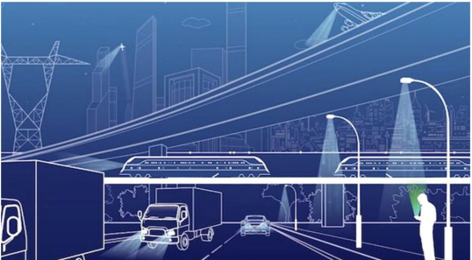

1. FUTURE SCOPE

Li-Fi has a bright future. More and more companies are working on building Li-Fi products and technology itself is advancing on a daily basis.

It may be that in the future Li-Fi will work with Wi-Fi. Both technologies have their pros and cons and when Li-Fi and Wi-Fi are used together they are compatible.

Some experts say that Li-Fi could be the basis for a single new sector combining the lighting industry and the wireless telecommunications industry.

As light is everywhere and is free to take advantage of opportunities increased Li-Fi usage significantly technology. If this technology will work individually the elevator lamp will be used as a Wi-Fi hotspot for transmission wireless data. As Li-Fi technology will be used this will lead to clean, green, safe and light the future and nature. The concept of Li-Fi says to attract as many people as it is free to use without any license and fast data transfer methods. In future people will make the most of this technology instead of Wi-Fi.

When Li-Fi technology comes into use each Li-Fi bulb can be used to transfer data wirelessly. The advancement of this technology could enable all street lights to be used in some way as a Wi-Fi hotspot for data transmission. It could be technology that can help you get in touch on the water, Land or airplane when the disturbance in the radio frequency was reduced communication. So we can say soon that we can use it light not only illuminate our homes but Li-Fi can use it to illuminate the world of transmission technology Li-Fi technology helps to provide green, clean, secure communication and have a positive future.

LI-FI The future can be thought of as light as the central navigation of our laptops, smart phones and tablets. And security would not be possible if the device did not have access to data. The New Startup Company from Tallinn, called Velmenni, recently conducted a practical Li-Fi technology test in a functional office. It has 46 internet connectivity speeds of up to 1Gbps - that's 100 times faster than bog standard Wi-Fi. Meanwhile, in lab cases, it has been discovered that Li-Fi can reach speeds of up to 224Gbps.Extensive research conducted on Li-Fi has discovered a new technology known as Gi-Fi or gigabit wireless, which targets wireless communication at a rate of more than one million bits per second. In 2008, a team of researchers at the University of Melbourne demonstrated the performance of a 60 GHz integrated transceiver in a single circuit integrated into the CMOS (Complementary Metal Oxide Semiconductor) process. It will allow audio and video data transfer of up to 5 Gigabits ’per second.

In addition, the system should be made less expensive by using energy savers. Creating a system that will support Li-Fi on almost all mobile devices.

1. PROBLEM STATEMENT

Signals produced through LI-FI cannot pass through object artifacts or even human so if a person or any objects come in its way of the receiver the signal will be lost. And also LIFI cannot work in darks because it is totally based on light. The service area of LIFI and the blockage are major issues in LIFI. It can be cause by many things like blockage, shadowing, overhead area, interference, and network resources (Blockage and shadowing differs from each other).

**BLOCKAGE:** It is the networks are entirely blocked, thereby leading to the Denial of Service in the stand-alone network.

**SHAWDOWING**: **Shadowing** means **that you receive** less optical **gain.**

When users cross the boundaries of a Li-Fi service area is affected and fluctuations in the network resources are triggered or occurred.

It is costly as it needs help from the eco system and the main reasons.

1. THESIS STATEMENT

As seen in the problem statement there are some problems faced by LIFI. In order to overcome it many methods have been introduced. Their solution includes the selection of Access points to provide Lighter and dense signals. It is more suited for indoor environments. The other includes the addition of more powerful light. This method is more suitable for outside places but this solution is inconvenient for indoor areas, where following international lighting standards is essential because it may hurt the human eyes and lead to discomfort.

1. CONCLUSION

As radio frequency (RF) is restricted to hospitals we therefore use Li-Fi to communicate. Patient details are sent to the doctor via Li-Fi communication. In addition we send the same information to the server so that if the doctor is not in the hospital he can find it online and make a decision. This program is very helpful in hospitals.

From the above study we analyze that in the future, data on laptops, smart phones and tablets can be transmitted speedily to a room via Li-Fi .Research is developing a micron-powered LED that can blink and turn on almost 1000 times faster than LED. They offer faster data transfer and take up less space so we can save space or add more LEDs to improve the communication channel. This technology can solve issues such as radio bandwidth shortages and allow the internet where traditional wireless radio does not allow such flights and hospitals. Another drawback is that it only applies to direct dealing.

If this technology is used properly then each bulb can use an analogous hotspot to transfer data wirelessly which is a better and cheaper way and if the technology is developed then it will definitely replace Wi- Fi limitations.

As more and more people and their devices enter the wireless internet, the airwaves are increasingly shutting down, making it increasingly difficult to obtain a reliable, high speed signal. This can solve issues such as the frequency bandwidth of frequency radio and allow for internet where traditional wireless is not allowed. In the future we will not only have 14 billion electric lamps, we will probably have 14 billion Li-Fi that will be distributed worldwide for a clean, green, and even bright future. “Now both light and radio waves can be used simultaneously to transmit data and signals.

In using this technology it is possible to use all the bulbs as a hotspot, which creates a safe environment. Since radio waves are harmful to living organisms and lead to the danger of birds we try to reduce this problem by using light reliability that works on the visible and harmless light frequencies. Another advantage of easy reliability is to reduce power consumption and data transfer with a high level of data where wi-fi finds it difficult to access. Utilizing this technology in the medical field makes diagnostics faster and allows access to the internet and radio-supported devices. There is also a flaw in this technology which means that there must be a certain line of sight and depending on the well-used bulb it is different. Therefore with the implementation of this technology it is possible to solve issues such as the shortage of radio frequency bandwidth and allow the internet where traditional wireless radios are not allowed as airlines or hospitals.

The concept of Li-Fi is currently attracting a lot of interest, not because it can offer a more realistic and efficient alternative to radio-based wireless. As more and more people and their devices enter the wireless internet, the airwaves are increasingly shutting down, making it increasingly difficult to obtain a reliable, high-speed signal. Distinctive physical features of the promise of light to deliver highly packaged connections at network speeds leading to higher orders for user data value. In light of these promising results, Li-Fi appears to be emerging as a potent solution for trouble free network communication in the forthcoming RF crisis, as well as future Internet-of-Everything technology. This can solve issues such as the lack of radio bandwidth and allow the internet where traditional wireless radio is not allowed such as airports or hospitals.

From a thorough study of what I did with Li-Fi, we can conclude that Li-Fi is a very good thing. That lights up the room and gives us great speed and secure internet at the same time. The efficiency of this technology cannot be compared to other technologies now. These technologies can shine cheaply in our pockets and healthcare. The health problems on Wi-Fi are small but, who wants to risk their lives.

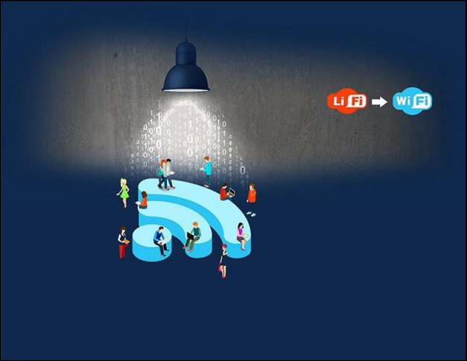

1. REFERENCES

<https://www.rfwireless-world.com/Terminology/LiFi-vs-WiFi.html#:~:text=LiFi%20stands%20for%20Light%20Fidelity,radio%20frequencies%20for%20data%20communication>.

<https://www.tutorialspoint.com/difference-between-wifi-and-lifi\>

<https://www.geeksforgeeks.org/difference-between-lifi-and-wifi/>

<https://www.lifi-centre.com/about-li-fi/benefits-of-li-fi/>

<https://www.techopedia.com/7/31772/technology-trends/what-are-the-advantages-and-disadvantages-of-li-fi-technology>

<https://www.geeksforgeeks.org/advantages-and-disadvantages-of-li-fi/>

<https://www.techywee.com/2020/12/Lifi-technology-wifi-technology.html>

<https://www.iop.org/explore-lifi-iop#gref>